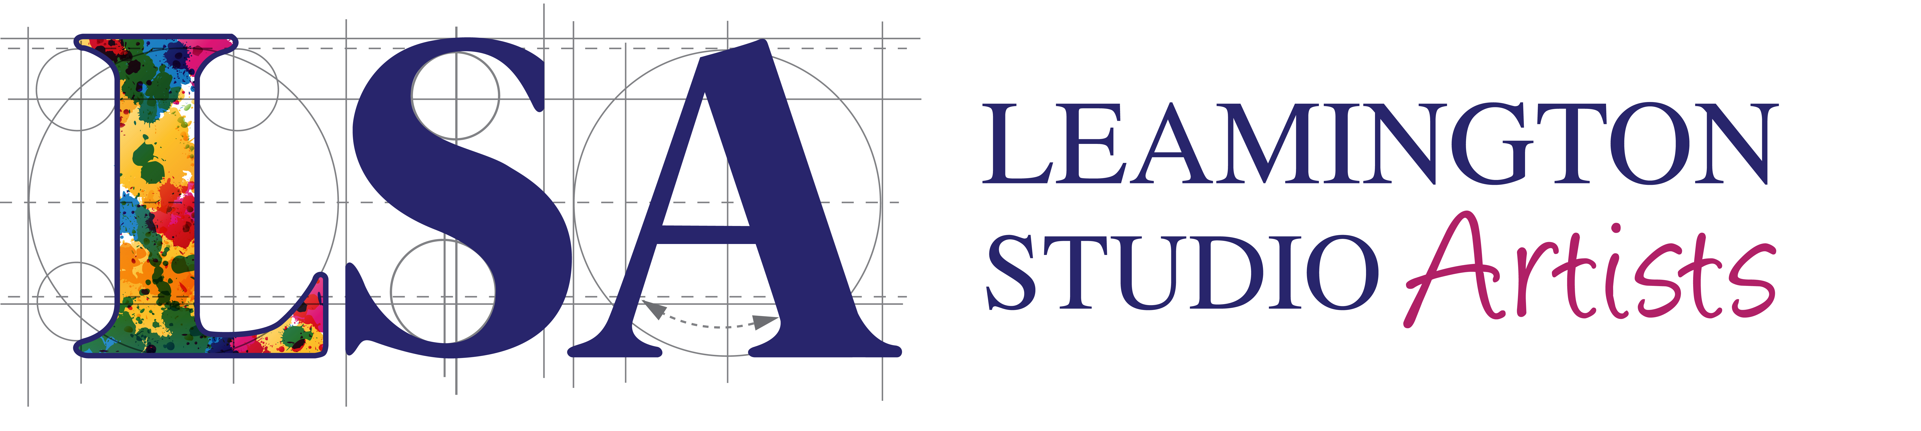
MEMBERSHIP FORM
Registered Charity No. 1147593
By providing your information you are consenting to its use in line with our Privacy Statement. Please take a moment to read this at http://lsa-artists.org/privacy/ before completing this form and returning it to
Vanessa Cooper, Membership Secretary, “Mill View” Golf Lane, Whitnash, Leamington Spa. CV31 2PY
Personal Details: | First Name
 | Surname
 | Email Address
 | House number
 | Street
 | Town
 | County
 | Postcode
 | Telephone
 | Website address
New Member/Renewal: |  |  |  |  |  | Tick Box
 | New Member |  |  |  |  | ☐
 | Renewal (existing member) |  |  |  |  | ☐
Membership Category:
 | Student Membership (£15) |  |  |  |  | ☐
 | Standard Membership (£25) |  |  |  |  | ☐
 | Family Membership (£30) |  |  |  |  | ☐
(Student members) Expected Date of Graduation:
(Family members) Name(s):
(Family members) Email(s):
(Family members) Website(s):
(Family members) Phone No.(s):
Artform/Media: If you are an artist, which type(s) of media do you work with?
Photography ☐ | Watercolours ☐ |  | Oils ☐ |  | Acrylics ☐
Sculpture ☐ | Mixed Media ☐ |  | Other:

Social Media: We’d like to follow you on social media. Please give details of your page/account:

Volunteer Opportunity: LSA is run entirely by volunteers. Can you help?
Existing volunteer with us? |  | Yes ☐ | Interested in volunteering |  |  |  | Yes ☐
Method of Payment: |  |  | Tick Box
 | Standing Order |  | ☐
 | Cash |  | ☐
 | Cheque |  | ☐
 | Bank Transfer |  | ☐

Signature: __________________________________________ Date: ______________________
Leamington Studio Artists Membership - Standing Order Mandate
Please complete and return to
Vanessa Cooper, Membership Secretary, “Mill View” Golf Lane, Whitnash, Leamington Spa. CV31 2PY

Bank Name
Bank Address
Please Debit my account:
Account Name:
Account Number: |  | Sort Code:
To pay: | Leamington Studio Artists (LSA),  East Lodge,  Willes Road  Leamington Spa,  CV32 4ER
Payment Reference: | LSA Subs
Beneficiary’s Bank: | Lloyds,  High Street,  Coventry,  PO Box 1000,  BX1 1LT
Account Number: | 01956944 | Sort Code: | 30-92-33
Amount: | £25 (twenty five pounds)*  £30 (thirty pounds)*  £15 (fifteen pounds)* | Standard Membership*  Family Membership*  Student Membership*
Date of first payment: | Immediately
 | And thereafter | Every year on (insert date):

* Delete as appropriate.

Until further notice in writing.

Please cancel any previous standing orders to Leamington Studio Artists.

Signature: _________________________________ Date: ________________________

Gift Aid Declaration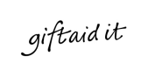
Leamington Studio Artists
Registered charity number: 1147593

Gift aid allows Leamington Studio Artists to receive an extra 25 pence for every £1 you give from H M Revenue and Customs. Please help us get 25 percent more from your contributions by completing the Gift Aid Declaration below.

Please treat as Gift Aid donations all qualifying gifts of money made by me to Leamington Studio Artists
Today | □ | In the past 4 years | □ | In the future | □
(Please tick all boxes you wish to apply)

I confirm I have paid or will pay an amount of Income Tax and/or Capital Gains Tax for each tax year (6 April to 5 April) that is at least equal to the amount of tax that all the charities or Community Amateur Sports Clubs (CASCs) that I donate to will reclaim on my gifts for that tax year. I understand that other taxes such as VAT and Council Tax do not qualify. I understand the charity will reclaim 28p of tax on every £1 that I gave up to 5 April 2008 and will reclaim 25p of tax on every £1 that I give on or after 6 April 2008.

Full Name
House Number
Street
Town
County
Postcode

Date: ______________ Signature: ____________________
Please notify Leamington Studio Artists if you:
- Want to cancel this declaration, Change your name or home address or no longer pay sufficient tax on your income and/or capital gains.
- If you pay Income Tax at the higher or additional rate and want to receive the additional tax relief due to you, you must include all your Gift Aid donations on your Self Assessment tax return or ask HM Revenue and Customs to adjust your tax code.

Student Membership is available to under 18yrs or full time students with a student card.
Family Membership is available to family members, including children, living at the same address.
Please complete the standing order mandate
Cash may be paid at East Lodge. Do not send cash in the post!
Make cheques payable to Leamington Studio Artists
Lloyds Bank account number 01956944 sort code 30-92-33

