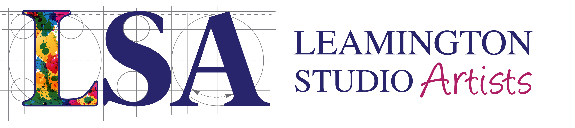

LSA Members’ Showcase: Water
31 July – 25 August 2019
This exhibition will take place during the month which includes the Art in the Park weekend and is following the theme of the festival. It’s a great opportunity for members to have their work seen by a very large number of visitors.
Submission Details and Requirements
All work submitted to this exhibition must follow the Water theme. Entries must be original work and may be in any medium.
Each LSA member may submit one piece. There is a selection process but we will endeavour to exhibit all submissions, subject to there being sufficient space. The entry fee is £10, which will be refunded to those not selected to exhibit.
The Maximum size of a wall hanging artwork is 40cm x 60 cm, including any frame. If the piece is slightly larger than this please contact the Curator or East Lodge Manager, but acceptance at submission is no guarantee of inclusion in the exhibition as demand is expected to be very high.
Canvases and framed works must be wire or cord strung. Stringing should be a third of the way down and using D rings. (No mirror plates please). Inappropriately prepared or wet/damp work will be rejected.
When submitting to the main exhibition, members may also submit up to 5 prints for display in browsers, at a cost of £2 each. Browser items must be individually mounted, backed with strong card and wrapped in cellophane.
If an artwork is sold and removed from the exhibition, you will be contacted and invited to provide a replacement at no charge. The replacement may not exceed the size of the original submission.
All works must be clearly marked on the reverse or underneath with: the artist’s name, the title of the work, price, a telephone number and email address.
Submission will take place on Monday 29th July 2019 between 10 am and 12 noon at East Lodge. All submissions must be accompanied by a completed submission form. The entry fees should be paid in cash at this time.
You are also invited to prepare a small card to be displayed alongside your work. This should include your name, your media/style, whether you take commissions, social media information and email/telephone number so that members of the public can contact you. The card must not be bigger than 10cm x 10cm, must be typed and in a readable size font. This card must be submitted with your work.
Unsold items should be collected on Sunday 25th August between 2 pm and 4pm. Failure to collect at this time, without prior arrangement with the Manager, will incur an additional £5 charge.
The LSA will not take responsibility for any loss or damage to artwork. Please ensure that you have adequate insurance in place.
There will be no commission fee charged on sales, but a 3% charge will be made for card payments.

